

4.9: If-Else-if-Else Statements

Now that we have our number being “sorted” into odd and even, we need to incorporate the divisible by 3 element. Let’s just try adding an else-if clause:

number = int(number)

if (number % 2 == 0):

print(str(number) + " is even")

elif (number % 3 == 0):

print(str(number) + " is divisible by 3")

else:

print(str(number) + " is odd and not divisible by 3")

You’ll notice that I have taken out the int(number) part from the if statement – this just reduces the number of times that it has to be evaluated by the computer.

When we run the program, we get the following different outputs:

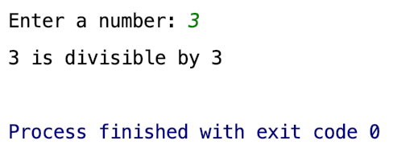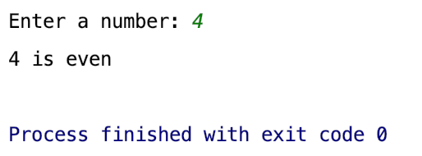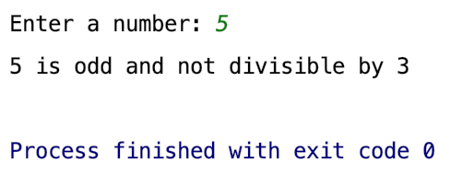

**Your Turn 3:**

Adapt your program payday program so that when Thursday is entered by the user it outputs:

“It’s nearly payday – one more sleep!”